THIS ENDORSEMENT CHANGES THE POLICY. PLEASE READ IT CAREFULLY.

USED TIRES EXCLUSION ENDORSEMENT

This endorsement modifies insurance provided under the following:

BUSINESS AUTO COVERAGE FORM
AUTO DEALERS COVERAGE FORM
COMMERCIAL GENERAL LIABILITY COVERAGE FORM

With respect to coverage provided by this endorsement, the provisions of the Coverage Form apply unless modified by this endorsement.

This endorsement changes the policy on the inception date of the policy unless another date is indicated below.

Named Insured:  Morris Avenue Auto Sales | Policy Number:
Endorsement Effective:  11/4/2025 | Countersigned By (Authorized Representative):  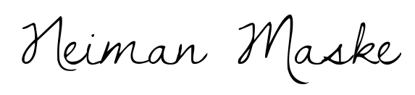

If no entry appears above, information required to complete this endorsement will be shown in the
Declarations.

1. BUSINESS AUTO COVERAGE FORM, SECTION II – COVERED AUTOS LIABILITY COVERAGE, B. Exclusions; AUTO DEALERS COVERAGE FORM, SECTION I – COVERED AUTOS COVERAGES, D. Covered Autos Liability Coverage, 4. Exclusions and AUTO DEALERS COVERAGE FORM, SECTION II – GENERAL LIABILITY COVERAGES, A. Bodily Injury And Property Damage Liability, 2. Exclusions are amended by the addition of the following:

Used Tires
“Bodily injury” or “property damage”, arising out of a defect in, or failure of, one or more tires which were
not new when sold or installed by the “insured”, its agent, “employee(s)” or independent contractor(s).

2. COMMERCIAL GENERAL LIABILITY COVERAGE FORM, SECTION I – COVERAGES, COVERAGE A –BODILY INJURY AND PROPERTY DAMAGE LIABILITY, 2. Exclusions is amended by the addition of the following:

Used Tires
“Bodily injury” or “property damage”, arising out of a defect in, or failure of, one or more tires which were
not new when sold or installed by the insured, its agent, “employee(s)” or independent contractor(s).

This endorsement shall apply to any continuation, reinstatement, or renewal of the captioned policy by the Named Insured.

I have read, understand and agree to the above statement and my signature and date are shown below.

_____________________________________ ______________________
Named Insured’s Signature Date

